Chapter 19, Problem 21.

Obtain the admittance parameter equivalent circuit of the two-port in Fig.19.82.

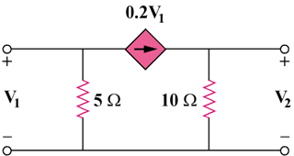

Figure 19.82
For Prob. 19.21

